

11th January 2016

Dear Parents

Please note the terms and conditions under which pre-school fees are paid and the amount of notice we require if you wish to reduce the number of hours your child attends at the setting:

Please read the following points carefully and let me know if you have any questions or concerns:

- Fees are payable half-termly, by the end of the second week, unless you make other arrangements with us.
- Failure to pay fees by the required date will result in an “Overdue Fees” reminder. If fees are overdue your child may lose their place.
- Refunds cannot be made for absence or holidays.
- Payment envelopes are issued each half term (unless otherwise agreed) as payments become due.
- We prefer payment by BACS, but also accept payment by cash or cheque (made payable to Rising Fives Pre-School Group) We also accept childcare vouchers.
- Please give fees to the member of staff taking the register or let us know when you paid by bank transfer.
- Fees are currently £4.25 per hour for any hours not covered by EYE or 2-year funding.
- If fees are outstanding when a child leaves the setting, we will seek recompense through the legal system if necessary.
- We require 6 weeks’ notice of a reduction of hours or of no longer requiring a place at the setting. In the absence of notice, you will be responsible for fees for the 6 week period. Notice should be given, either in writing or via email, to the manager or deputy. Notice is automatic when a child leaves to go to school.
- Where possible, we will accommodate increases in sessions or changes that do not reduce total hours at short notice, but we would appreciate these changes being kept to a minimum as considerable administrative time is often involved in making a change.

If you require any further information, please let me know.

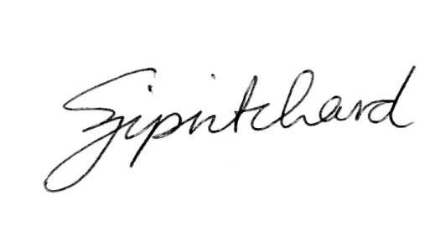
Yours sincerely

Sarah Pritchard, Manager

